Squash All Commits Into One Git

Find how many commits to Squash in single commit & from existing commits.

$ git log --online ( it show commits on head )

Now planing how many commits need to SQUASH

$ git rebase -i HEAD~4 (4 == number of commits we need to plan )

Seperate window will open.

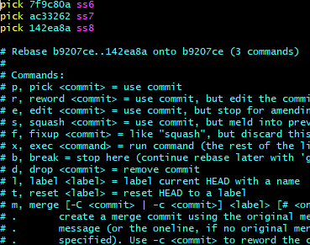

If we maintain PICK that means we are squash old commits into that commit.

We rename PICK in to ‘S’ that means which commits need to squash

Reference given below image.



Use Esc+ wq! To save and quit from window.

After that it open commit data

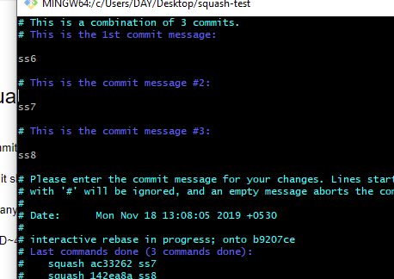

We can add what we need commit message as shown below .

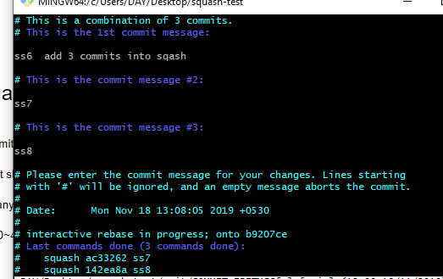

Use Esc+ wq! To save and quit from window.

Finally in termina u will see the information.

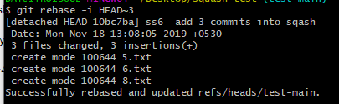

After squash is done it show like that.

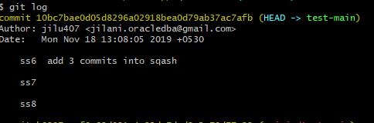

$ git push -u origin BRANCH-NAME

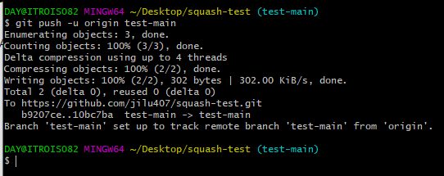

##################### Done ###########